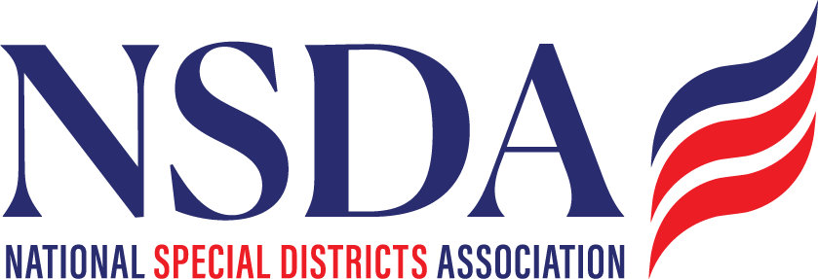

NSDC Federal Advocacy Committee

Meeting Summary

2.6.2025

Welcome and Updates: Chantal Unfug

* Chantal Unfug opened the meeting and acknowledged the January 2025 meeting summary.

Federal Advocacy Update: Paragon Government Affairs

General DC Overview: Uncertainty is the key word.

* + Focus on funding processes, “How to Pay for”, deadlines, and potential government shutdown concerns.
  + Discussions on FY 2026 budget planning and potential bipartisan negotiations.
* FY 2025 Budget Reconciliation Process
  + House and Senate have approved competing budget blueprints
* FY 2025 Appropriations
  + Current Continuing Resolution expires March 14 and remains a key issue
  + FY 2026 Appropriations process is around the corner, discussions beginning, but will be behind
  + House and Senate have approved competing budget blueprints, and negotiations continue.

Update on Special Districts Definition Bill

* + Updates on committed House and Senate sponsors. No changes.
  + Timing for introduction remains fluid but expected in end of April.
  + Continued grassroots efforts are necessary- continue to promote sign on support
  + Sponsors Press strategy is being developed.
  + NSDA updating resources and tool box for when Bill drops
  + NSDA Federal Funding Access Questionnaire
  + NSDA Priorities & Advocacy Targets: Key states include TX, FL, WY, SC, and AZ (Freedom Caucus focus).
  + Reminder note: Don’t say “NSDA’s” bill or “our” bill – remember it's the Congressmembers’ bill!
  + The Special District Fairness and Accountability Act name was decided by Rep Fallonand appears to be sticking.

Trump Administration Federal Funding Freeze

* + Discussed implications of the Trump Administration’s federal funding freeze. May programs have been lifted already.
  + Litigation is ongoing, and members are encouraged to contact their Congressional representatives if they see continued impacts.

Fix Our Forests Act

* + Cleared by the House; pending Senate consideration.
  + Advocacy continues to push for passage.

Disaster Assistance Legislation

* Uncertainty on committee progress; need to verify Senate companion bill status.

ASAE – NSDA Survey & Communications (Kyle)

* + Discussion on articles to be sent and messaging strategy.
  + Request for members to repost, like share the ASAE social media
  + Plan to embed survey links in association newsletters on collaborations with Non Profits

EPA:

* The public comment period for the EPA Water Quality Human Health Criteria has been extended to April 25.
* The public comment period for the EPA Biosolids Risk Assessment has been extended to April 16.

DC Days Planning: Meeting scheduled for Monday with Chantal and Paragon. Discuss WH Office of Public Engagement

Reminder: Federal Policy Program and Alerts will be on the website:

<https://www.nationalspecialdistricts.org/federal-advocacy>

Action Items & Next Steps

* Continue grassroots efforts for the Special Districts Definition Bill.
* Follow up on Senate progress for the Fix Our Forests Act.
* Look up status of the Disaster Assistance Committee bill.
* Share and engage with NSDA survey and advocacy posts.
* Share ASAE social media posts
* Monitor developments in federal budget negotiations and appropriations.
* Prepare for DC Days advocacy meetings.

Next Meeting: March 27 & April 24, 2025