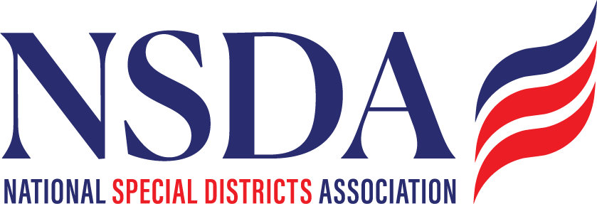

**NSDC Federal Advocacy Committee**

**Agenda**

**3.27.2025**

**1:00 pm MNT time**

*Join Zoom Meeting: https://us06web.zoom.us/j/85240694788?pwd=cFaB1TfCFa370f9hHB8T7easZI2uc1.1*

*Meeting ID: 852 4069 4788*

*Passcode: 818259*

*One tap mobile*

*+17193594580,,85240694788#,,,,*818259# US*

*+13462487799,,85240694788#,,,,*818259# US (Houston)*

**Welcome and Updates:** **Chantal Unfug**

* Welcome

**Federal Advocacy Update: Paragon Government Affairs**

**General DC Overview**

* General DC Overview
  + Recap of Long-Term Continuing Resolution (CR)
  + Up Next - Budget Reconciliation (Tax Reform & Spending Cut Package)
  + Potential Offset: Tax-exempt status of municipal bonds
* Special District Definition Bill
  + Ongoing Discussions and Meetings
* NSDA Fly-in
  + Agenda, Meeting Schedule, and Materials are being developed
* Next meeting date: April 24, 2025
* Reminder: Federal Policy Program and Alerts will be on the website:

<https://www.nationalspecialdistricts.org/federal-advocacy>