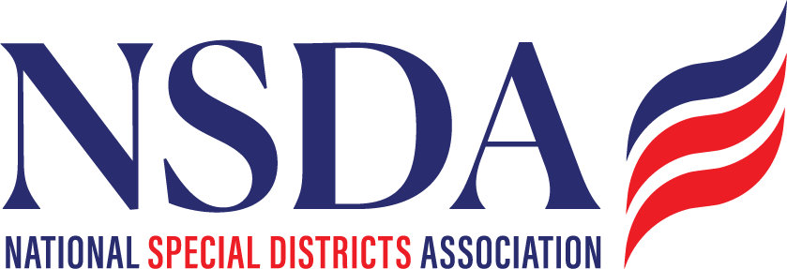 **Your logo here**

**Template Email to Share with Your Network**

**Subject:** Join Us in Protecting the Tax-Exempt Sector

Dear [Recipient's Name],

I wanted to personally reach out to share an important initiative that in Partnership with the National Special District Association, [ORGANIZATION NAME] has joined—the **Community Impact Coalition**. This coalition is focused on protecting the tax-exempt sector, which plays a crucial role in supporting jobs, services, and communities across the country.

Right now, ​​Congress is considering policies that could threaten the tax-exempt sector. It’s critical that we raise our voices and ensure lawmakers understand the importance of safeguarding these organizations and the vital work they do.

Click here if you’re interested in learning more:  <https://www.cicoalition.org/>

To help spread awareness and support our cause, we’ve also developed several key resources:

* **Coalition Launch Video** – Our official video is live on the landing page and [YouTube](https://youtu.be/Hwjpa5cXkBc?si=p8DiTfzDmvxgtooc). This is a great tool to post on social and help explain why this issue matters—please watch and share it.
* **Coalition Toolkit** – Available for download on the landing page, this includes FAQs, an informational handout, and key messaging resources to help you discuss the coalition’s mission and mobilize support.
* **Social Media Channels** – Engagement is critical to expanding our reach. Follow and tag us on:
  + **Twitter/X:** [@CI_Coalition](https://x.com/CI_Coalition)
  + **LinkedIn:** [communityimpactcoalition](https://www.linkedin.com/company/communityimpactcoalition/about/" \o "https://www.linkedin.com/company/communityimpactcoalition/about/)
  + **Facebook:**[communityimpactcoalition](https://www.facebook.com/communityimpactcoalition" \o "https://www.facebook.com/communityimpactcoalition)