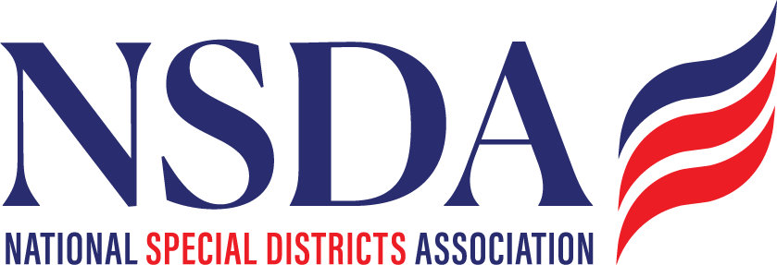

NSDA Federal Advocacy Committee – Meeting Summary
March 27, 2025 | 1:00 PM MT
Welcome and Updates
Ann Terry welcomed attendees and previewed key federal issues impacting special districts.
Federal Advocacy Update, Paragon Government Affairs
General DC Overview
- Congress passed and the President signed a long-term Continuing Resolution (CR) in March, extending government funding through September 30, 2025, using the FY 2024 baseline.
- The budget resolution process is ongoing, aiming for savings to mandatory spending and potential tax cuts. Congress seeks to adopt a single resolution directing committees to find savings.
- The next several weeks (March–April) are pivotal for outlining a budget blueprint and drafting legislation.
- Discussions continue around the tax-exempt status of municipal bonds, though no conference report has emerged. Pushback is expected, and NSDA will continue monitoring.
- Earmarks will not be available for FY 2025. Projects not yet funded or under contract may be at risk.
- Committee markups are expected sooner than usual; Speaker Johnson is pushing to complete these by Memorial Day.
ASAE Update
Kyle Packham reported on ASAE Lobby Day in Washington, D.C.:
- Representative Tom McClintock remains opposed to all grant programs.
- Tax policy and education continue to dominate the federal agenda, with all major tax-writing committees engaged.
- On the Fix Our Forests Act, Kyle, CSDA’s forestry fellow, and resource districts met with Rep. Adam Schiff’s office. Senator Alex Padilla is leading the drafting effort and they are working toward bipartisan support.
GEMT Programs
Frank Stratton discussed federal funding related to Ground Emergency Medical Transportation (GEMT).
- Low Medicaid reimbursement rates threaten ambulance services across the U.S.
- GEMT funds are crucial to cover these shortfalls.
- Tom (Paragon) will connect NSDA with Nicole, Chief of Staff, for federal follow-up.
- NSDA is asked to gather real-life examples from members to support advocacy efforts.
Presidential Executive Order on Disaster Response
The Executive Order titled “Achieving Efficiency Through State and Local Preparedness” proposes:
- Establishing a National Risk Center and National Critical Infrastructure Policy.
- A shift in FEMA’s role—moving away from broad responsibility to more immediate disaster response only.
- Public input on FEMA’s effectiveness is being collected through May 15, 2025:
👉 https://www.federalregister.gov/documents/2025/03/26/2025-05057/request-for-public-input-on-experiences-with-fema-disaster-responses
- Recent hearings have also discussed State and Local Government Grant Programs under the Disaster Aid Simplification Act.
Special District Definition Bill
Paragon Government Relations has continued outreach on the Defining Special Districts Act:
- Meetings held with seven senators, generating strong interest and ongoing follow-up.
- Terry remains in communication with Rep. Scott Peters.
- California delegation was thanked for their involvement and support.
Other Business
Jonathan Roach (Texas) shared that the Texas Special District Coalition MOU has been signed.
- While not yet public, a press release and photographs are available for internal use.
- This development will support the upcoming summer event in Austin.
Next Meeting
🗓 April 24, 2025
📢 Stay informed: https://www.nationalspecialdistricts.org/federal-advocacy

