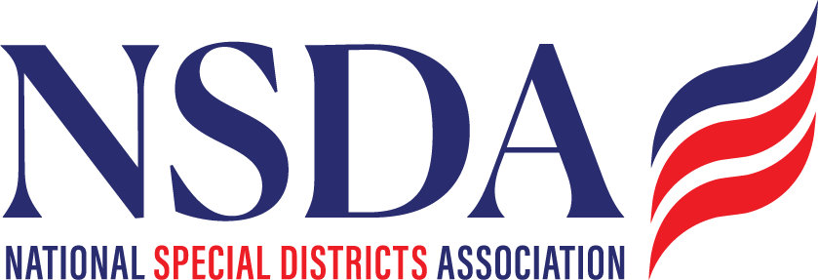

**NSDC Federal Advocacy Committee**

**Agenda**

**2.6.2024**

**1:00 pm MNT time**

*Join Zoom Meeting: https://us06web.zoom.us/j/85240694788?pwd=cFaB1TfCFa370f9hHB8T7easZI2uc1.1*

*Meeting ID: 852 4069 4788*

*Passcode: 818259*

*One tap mobile*

*+17193594580,,85240694788#,,,,*818259# US*

*+13462487799,,85240694788#,,,,*818259# US (Houston)*

**Welcome and Updates:** **Ann Terry, Chair**

* Welcome
* Meeting Summary

**Federal Advocacy Update: Paragon Government Affairs**

**General DC Overview**

* FY 2025 Budget Reconciliation Process
  + House and Senate have approved competing budget blueprints
* FY 2025 Appropriations
  + Current Continuing Resolution expires March 14
* FY 2026 Appropriations process is around the corner

**Update on Special Districts Definition Bill**

* House and Senate Sponsors (Committed)
* Timing for Introduction
* Continuing Grassroots efforts
* Press strategy, etc.
* NSDA Federal Funding Access Questionnaire

**Trump Administration Federal Funding Freeze**

* Litigation Update

**Fix Our Forests Act**

* Legislation (H.R. 471) cleared by House; Pending in Senate

**Other Items:**

* Next meeting date: April 24, 2025
* Reminder: Federal Policy Program and Alerts will be on the website:

<https://www.nationalspecialdistricts.org/federal-advocacy>